DESIGN | CODE | DESCRIPTION | QYANTITY
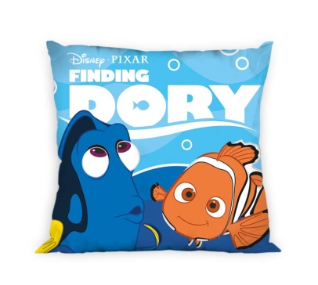 | 5207162000007 | Cushion 40x40cm, 85gsm, filling 250gr, 100% Polyester "Finding Dory 1" | 794
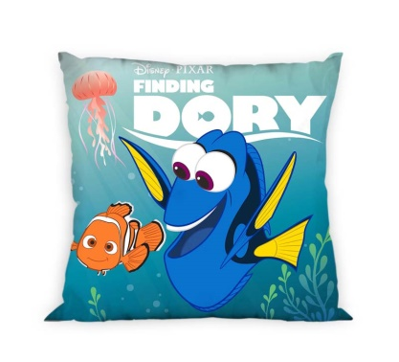 | 5207162000007 | Cushion 40x40cm, 85gsm, filling 250gr, 100% Polyester "Finding Dory 2" | 1154
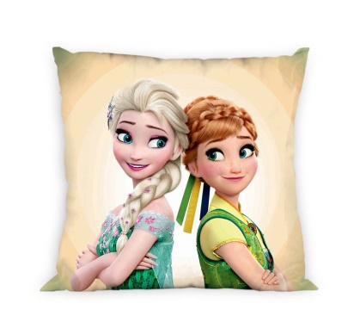 | 5207162000014 | Cushion 40x40cm, 85gsm, filling 250gr, 100% Polyester "Frozen Sisters" | 434
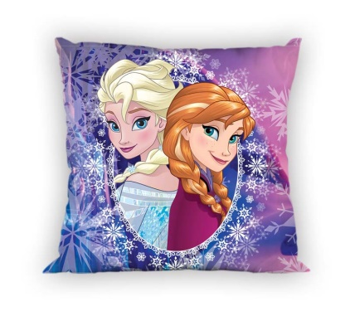 | 5207162000014 | Cushion 40x40cm, 85gsm, filling 250gr, 100% Polyester "Frozen Blue" | 341
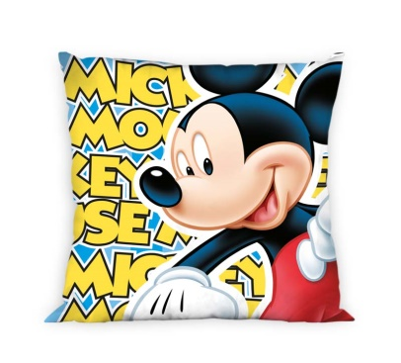  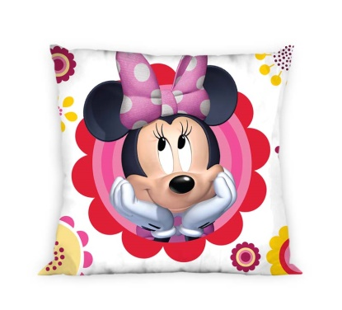 | 5207162000021 | Cushion 40x40cm, 85gsm, filling 250gr, 100% Polyester "Mickey" | 605
 | 5207162000038 | Cushion 40x40cm, 85gsm, filling 250gr, 100% Polyester "Minnie" | 1035
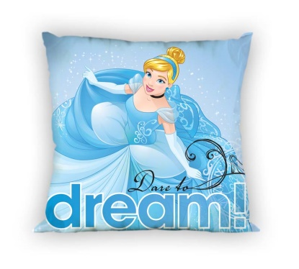 | 5207162000045 | Cushion 40x40cm, 85gsm, filling 250gr, 100% Polyester "Princess Dare to Dream" | 1210
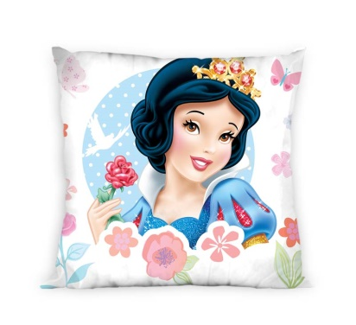 | 5207162000045 | Cushion 40x40cm, 85gsm, filling 250gr, 100% Polyester "Snow White" | 1135
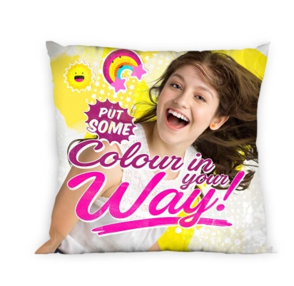 | 5207162000052 | Cushion 40x40cm, 85gsm, filling 250gr, 100% Polyester "Soy Luna CINW" | 1312
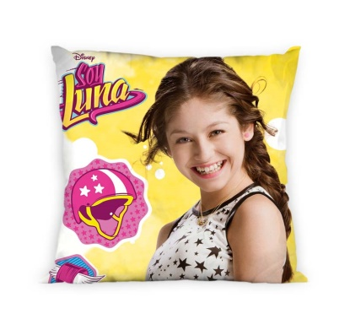 | 5207162000052 | Cushion 40x40cm, 85gsm, filling 250gr, 100% Polyester "Soy Luna Smile" | 1252
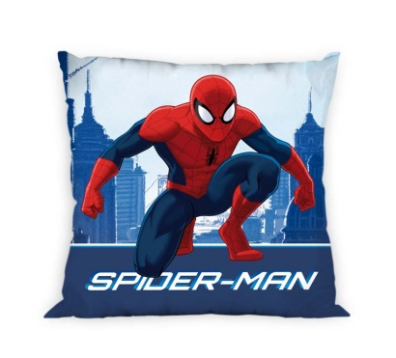 | 5207162000069 | Cushion 40x40cm, 85gsm, filling 250gr, 100% Polyester "Spiderman Blue" | 1245
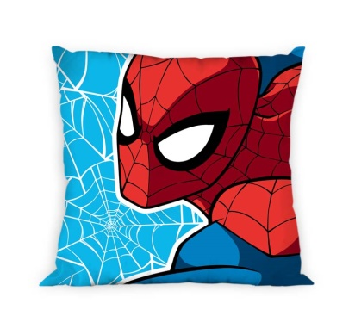 | 5207162000069 | Cushion 40x40cm, 85gsm, filling 250gr, 100% Polyester "Spiderman BB" | 1160
 |  | TOTAL: | 11677

